

|  |
| --- |
| **GSC – Time Entry Validation** |

**Use Case Diagram**

Author: Nievha Ellainne Sia

August 28, 2015

Confidential

# Copyright

Copyright © 2011 Gurango Software Corporation

All rights reserved.

Information in this document is prepared by Gurango Software Corporation for improving the Time entry system to help the organization for registering and tracking employee attendance, it can integrate with existing payroll and human resource systems, as well as various collection devices. It can also help the project manager track the progress of the projects. The software described in this document is furnished under a license agreement or nondisclosure agreement. The software may be used or copied only in accordance with the terms of those agreements. No part of this document may be reproduced, stored in a retrieval system, or transmitted in any form or by any means without the prior written permission of the company.

**Gurango Software Corporation**

Units 7-8 G/F Topy's Place Building,

Industria cor. Economia St.,

Barangay Bagumbayan, Libis, Quezon City

Philippines 1110

Telephone: + 63 (2) 637-0928

Facsimile : + 63 (2) 636-3800

www.gurango.com

# Table of Contents

Copyright 2

Table of Contents 3

1. Introduction 4

1.1. Purpose 4

1.2. Objective 4

2. GSC: TES Module 5

3. Actors and Use Cases 6

3.1. Actors 6

3.2. Use Cases 6

# Introduction

## Purpose

The purpose of the Use Case Diagram is to overview the usage and requirements of the time entry system, and its dynamic behavior.

## Objective

This document is intended to impart knowledge to those part of the development of “GSC: Time Entry Validation” of the system. This describes the flow and scenarios upon transaction.

# GSC: Time Entry System Module

Time Entry System is software that helps organization for registering and tracking employee attendance, it can integrate with existing payroll and human resource systems, as well as various collection devices. It can also help the project manager track the progress of the projects.

The figure below **Figure 1. Use Case Diagram: Time Entry System** shows the Use Case Diagram for Time Entry System (TES) for Gurango Software Corporation (GSC) employees.

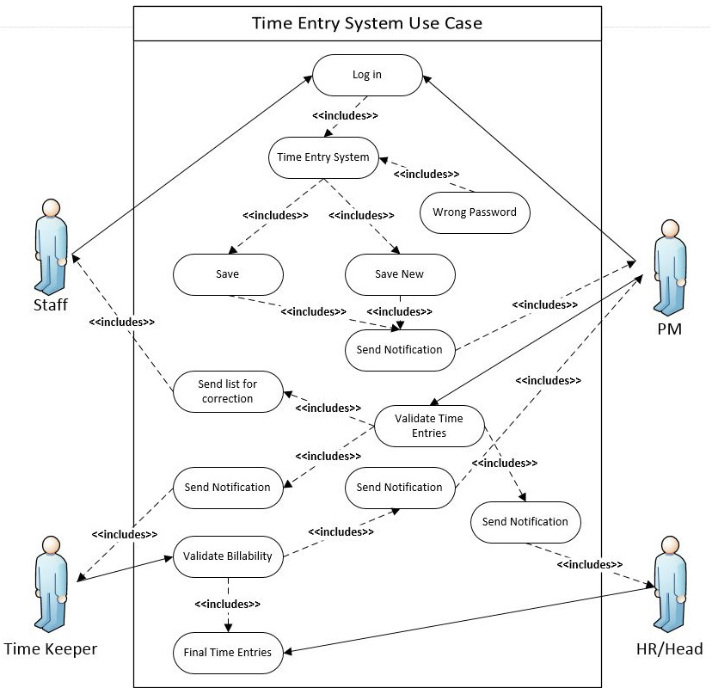

**Figure 1. Use Case Diagram: Time Entry System**

# Actors and Use Cases

## Actors

**Staff**

This actor will enter the records of what they did that day it is also their attendance manually.

**Project Manager**

This actor serves as the immediate approver for the time entries of their staff if there is any correction that requires a detail modification. This actor may add, remove, search, view employee information or designation information and more

**Time keeper**

In a hierarchical basis, this actor will receive a notification once they are the one in line to approve the application. They will be also responsible for records in billability status of the project.

**HR/Head**

This will also get a notification from the PM regarding on the Log violation.

## Use Cases

**Log in**

This action can performed by any employee in the company. This implies the filling up the username and password to sign in to time entry.

**Wrong Password**

This action indicates that the user inputs wrong password.

**Time Entry System**

This action can performed by any employee in the company. This indicates the filling up the time entry for the week.

**Save**

After executing this action, a record will be automatically created in TES and you can no longer delete it, rather you can edit its content. And a notification will be sent to the project manager for approval.

**Save New**

After executing this action, a record will add/save new record to the time entry. And will also send notification to the project manager for approval.

**Send Notification**

Use Case that is looped until the application reaches the final approver and approved it.

**Validate Time Entries**

This action is to validating the time entries. This action is for the project manager to check the time entries of their staff and validate it.

**Validate Billability**

This action is to validating the time entries of the employees focusing on the billability of the project.

**Final Time Entries**

This action is for the Head/HR so they can search, view employee information or designation information and more.